# Mysqlslab Redis-benchmark 和 wrk

1. Mysqlslab

mysqlslap -a -u root -p123456 --concurrency=100 --number-of-queries=100  
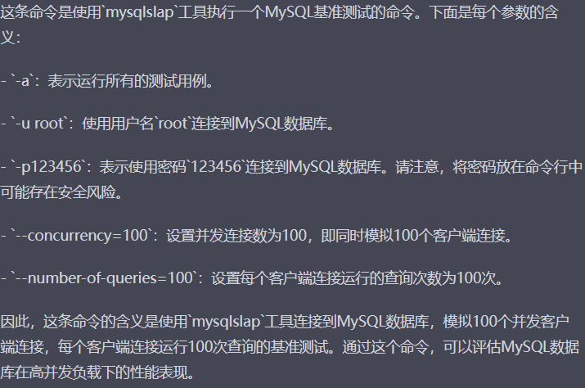

# 

####

mysqlslap -u root -p123456 --delimiter=';' --create="create table a(b int); insert into a values(23)" --query="select * from a;" --concurrency=100 --iterations=100

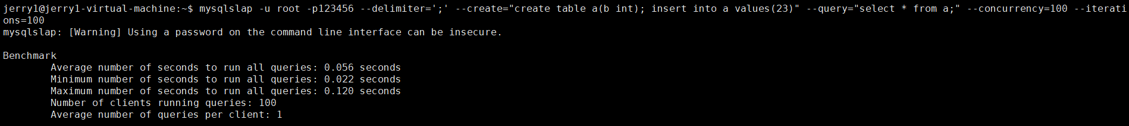

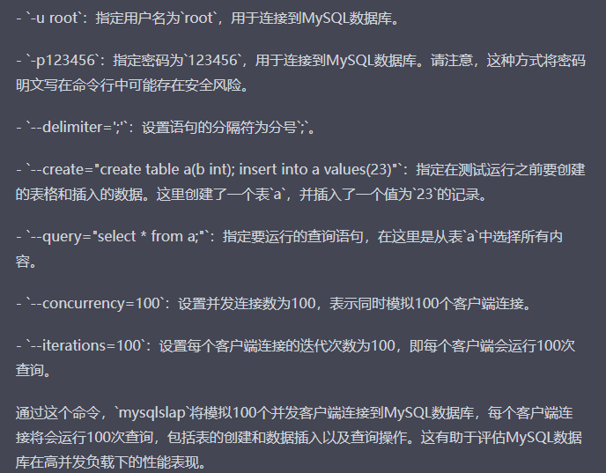

####

mysqlslap --create='create table user(uname varchar(50), age int);' -q "select * from user" -c 2 --number-of-queries=100 -uroot -p

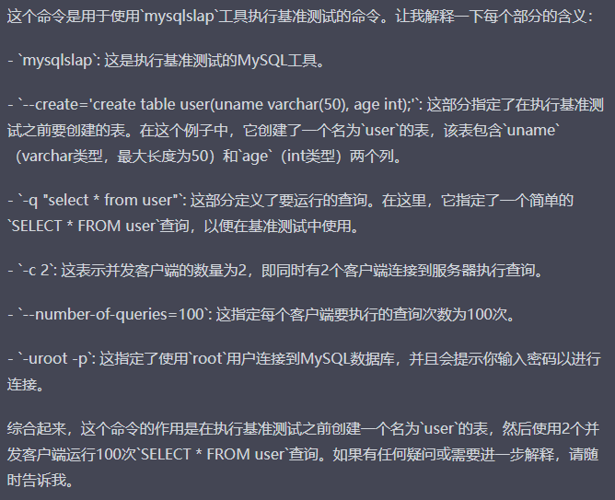

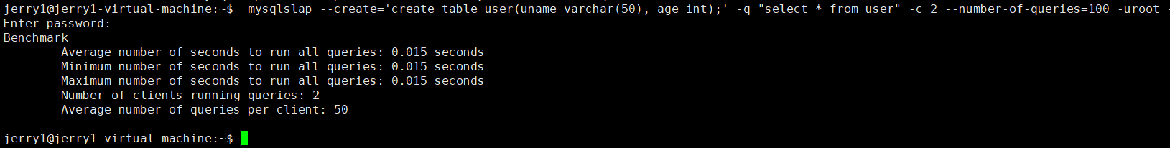

####

mysqlslap --create='create table user(uname varchar(50), age int);' -q "insert into user values('aaa', '22')" -c 2 --number-of-queries=100 -uroot -p

2.Redis-benchmark

redis-benchmark -h 127.0.0.1 -p 6379 -c 20 -n 10000 -q

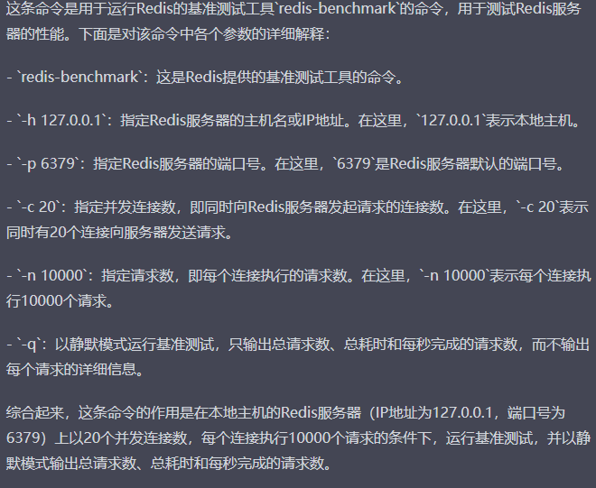

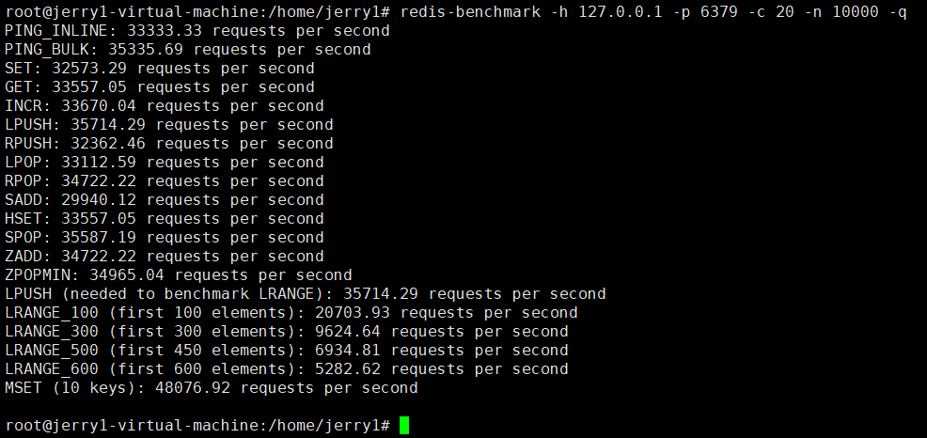

####

redis-benchmark -h 127.0.0.1 -p 6379 -c 20 -n 10000 -q script load "redis.call('zrange', 'zvoice', '0', '10')"

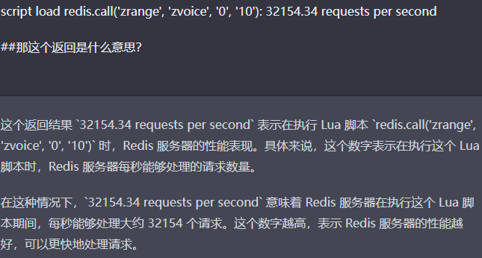

3.Wrk

./wrk -t 20 -c 50 -d30s https://www.0voice.com/

